**Chatarina Natassya Putri**

**06.2021.1.07482**

**UAS**

**Pengelolahan Citra Digital**

**Source code :**

% Tentukan path ke direktori tempat gambar disimpan

path_to_images = 'D:\kuliah\semester 5\Pengelolahan Citra Digital\Chatarina Natassya P_UAS_PCD_07482_P'; % Ganti dengan path yang sesuai

% Ganti direktori kerja MATLAB ke path gambar

cd(path_to_images);

num_objects = 5; % Jumlah objek gambar

% Inisialisasi variabel metrik evaluasi dan PSNR untuk setiap metode

TPR_asli_kontras = zeros(1, num_objects);

FNR_asli_kontras = zeros(1, num_objects);

FPR_asli_kontras = zeros(1, num_objects);

TNR_asli_kontras = zeros(1, num_objects);

MSE_asli_kontras = zeros(1, num_objects);

PSNR_asli_kontras = zeros(1, num_objects);

TPR_kontras_high_pass = zeros(1, num_objects);

FNR_kontras_high_pass = zeros(1, num_objects);

FPR_kontras_high_pass = zeros(1, num_objects);

TNR_kontras_high_pass = zeros(1, num_objects);

MSE_kontras_high_pass = zeros(1, num_objects);

PSNR_kontras_high_pass = zeros(1, num_objects);

TPR_asli_high_pass_direct = zeros(1, num_objects);

FNR_asli_high_pass_direct = zeros(1, num_objects);

FPR_asli_high_pass_direct = zeros(1, num_objects);

TNR_asli_high_pass_direct = zeros(1, num_objects);

MSE_asli_high_pass_direct = zeros(1, num_objects);

PSNR_asli_high_pass_direct = zeros(1, num_objects);

% Cell array untuk menyimpan gambar

result_images = cell(1, num_objects);

for obj = 1:num_objects

% Baca citra asli

file_asli = ['default' num2str(obj) '.jpg']; % Format nama file sesuai dengan kebutuhan

foto_asli = imread(file_asli);

% Konversi ke grayscale jika foto_asli adalah RGB

if size(foto_asli, 3) == 3

foto_asli = rgb2gray(foto_asli);

end

% Metode Kontras

kontras_factor = 1.5;

[m, n] = size(foto_asli);

foto_kontras = zeros(m, n);

for i = 1:m

for j = 1:n

% Kalkulasi kontras

foto_kontras(i, j) = min(max(0, kontras_factor * double(foto_asli(i, j))), 255);

end

end

foto_kontras = uint8(foto_kontras);

% Hitung metrik evaluasi dan MSE untuk asli ke kontras

TPR_asli_kontras(obj) = sum(foto_asli(:) >= 245 & foto_kontras(:) >= 245);

FNR_asli_kontras(obj) = sum(foto_asli(:) >= 245 & foto_kontras(:) < 245);

FPR_asli_kontras(obj) = sum(foto_asli(:) < 245 & foto_kontras(:) >= 245);

TNR_asli_kontras(obj) = sum(foto_asli(:) < 245 & foto_kontras(:) < 245);

MSE_asli_kontras(obj) = mean((double(foto_kontras(:)) - double(foto_asli(:))).^2);

% Hitung PSNR untuk asli ke kontras

if MSE_asli_kontras(obj) > 0

max_intensity = double(max(foto_asli(:)));

PSNR_asli_kontras(obj) = 10 * log10((max_intensity^2) / MSE_asli_kontras(obj));

else

PSNR_asli_kontras(obj) = inf;

end

% Metode High-pass

kernel_high_pass = [0 -1 0; -1 5 -1; 0 -1 0];

foto_high_pass = conv2(double(foto_kontras), kernel_high_pass, 'same');

% Hitung metrik evaluasi dan MSE untuk kontras ke high-pass

TPR_kontras_high_pass(obj) = sum(foto_kontras(:) >= 245 & foto_high_pass(:) >= 245);

FNR_kontras_high_pass(obj) = sum(foto_kontras(:) >= 245 & foto_high_pass(:) < 245);

FPR_kontras_high_pass(obj) = sum(foto_kontras(:) < 245 & foto_high_pass(:) >= 245);

TNR_kontras_high_pass(obj) = sum(foto_kontras(:) < 245 & foto_high_pass(:) < 245);

MSE_kontras_high_pass(obj) = mean((double(foto_high_pass(:)) - double(foto_kontras(:))).^2);

% Hitung PSNR untuk kontras ke high-pass

if MSE_kontras_high_pass(obj) > 0

max_intensity = double(max(foto_kontras(:)));

PSNR_kontras_high_pass(obj) = 10 * log10((max_intensity^2) / MSE_kontras_high_pass(obj));

else

PSNR_kontras_high_pass(obj) = inf;

end

% Segmentasi langsung dari asli ke high pass tanpa melalui kontras

kernel_high_pass = [0 -1 0; -1 5 -1; 0 -1 0];

foto_high_pass_direct = conv2(double(foto_asli), kernel_high_pass, 'same');

% Hitung metrik evaluasi dan MSE untuk asli ke high pass tanpa melalui kontras

TPR_asli_high_pass_direct(obj) = sum(foto_asli(:) >= 245 & foto_high_pass_direct(:) >= 245);

FNR_asli_high_pass_direct(obj) = sum(foto_asli(:) >= 245 & foto_high_pass_direct(:) < 245);

FPR_asli_high_pass_direct(obj) = sum(foto_asli(:) < 245 & foto_high_pass_direct(:) >= 245);

TNR_asli_high_pass_direct(obj) = sum(foto_asli(:) < 245 & foto_high_pass_direct(:) < 245);

MSE_asli_high_pass_direct(obj) = mean((double(foto_high_pass_direct(:)) - double(foto_asli(:))).^2);

% Hitung PSNR untuk asli ke high pass tanpa melalui kontras

if MSE_asli_high_pass_direct(obj) > 0

max_intensity = double(max(foto_asli(:)));

PSNR_asli_high_pass_direct(obj) = 10 * log10((max_intensity^2) / MSE_asli_high_pass_direct(obj));

else

PSNR_asli_high_pass_direct(obj) = inf;

end

% Menyimpan gambar dalam cell array

result_images{obj} = {foto_asli, foto_kontras, uint8(foto_high_pass)};

end

% Tampilkan metrik akurasi, sensitivitas, spesifisitas, MSE, dan PSNR untuk setiap objek dan metode

fprintf('Metrik untuk Asli ke Kontras:\n');

for obj = 1:num_objects

fprintf('Objek %d:\n', obj);

fprintf(' Akurasi: %12.4f\n', ((TPR_asli_kontras(obj) + TNR_asli_kontras(obj)) / (TPR_asli_kontras(obj) + FNR_asli_kontras(obj) + FPR_asli_kontras(obj) + TNR_asli_kontras(obj))) * 100);

fprintf(' Sensitivitas: %12.4f\n', (TPR_asli_kontras(obj) / (TPR_asli_kontras(obj) + FNR_asli_kontras(obj))) * 100);

fprintf(' Spesifisitas: %12.4f\n', (TNR_asli_kontras(obj) / (TNR_asli_kontras(obj) + FPR_asli_kontras(obj))) * 100);

fprintf(' MSE: %12.4f\n', MSE_asli_kontras(obj));

fprintf(' PSNR: %12.4f\n', PSNR_asli_kontras(obj));

fprintf('\n');

end

fprintf('Metrik untuk Kontras ke High-pass:\n');

for obj = 1:num_objects

fprintf('Objek %d:\n', obj);

fprintf(' Akurasi: %12.4f\n', ((TPR_kontras_high_pass(obj) + TNR_kontras_high_pass(obj)) / (TPR_kontras_high_pass(obj) + FNR_kontras_high_pass(obj) + FPR_kontras_high_pass(obj) + TNR_kontras_high_pass(obj))) * 100);

fprintf(' Sensitivitas: %12.4f\n', (TPR_kontras_high_pass(obj) / (TPR_kontras_high_pass(obj) + FNR_kontras_high_pass(obj))) * 100);

fprintf(' Spesifisitas: %12.4f\n', (TNR_kontras_high_pass(obj) / (TNR_kontras_high_pass(obj) + FPR_kontras_high_pass(obj))) * 100);

fprintf(' MSE: %12.4f\n', MSE_kontras_high_pass(obj));

fprintf(' PSNR: %12.4f\n', PSNR_kontras_high_pass(obj));

fprintf('\n');

end

fprintf('Metrik untuk Citra Asli ke High Pass tanpa melalui kontras:\n');

for obj = 1:num_objects

fprintf('Objek %d:\n', obj);

fprintf(' Akurasi: %12.4f\n', ((TPR_asli_high_pass_direct(obj) + TNR_asli_high_pass_direct(obj)) / (TPR_asli_high_pass_direct(obj) + FNR_asli_high_pass_direct(obj) + FPR_asli_high_pass_direct(obj) + TNR_asli_high_pass_direct(obj))) * 100);

fprintf(' Sensitivitas: %12.4f\n', (TPR_asli_high_pass_direct(obj) / (TPR_asli_high_pass_direct(obj) + FNR_asli_high_pass_direct(obj))) * 100);

fprintf(' Spesifisitas: %12.4f\n', (TNR_asli_high_pass_direct(obj) / (TNR_asli_high_pass_direct(obj) + FPR_asli_high_pass_direct(obj))) * 100);

fprintf(' MSE: %12.4f\n', MSE_asli_high_pass_direct(obj));

fprintf(' PSNR: %12.4f\n', PSNR_asli_high_pass_direct(obj));

fprintf('\n');

end

% Tampilkan citra asli, hasil kontras, dan hasil high-pass dalam satu figure

figure;

for obj = 1:num_objects

subplot(3, num_objects, obj);

imshow(result_images{obj}{1}); % Tampilkan citra asli

title(['Citra Asli ' num2str(obj)]);

subplot(3, num_objects, obj + num_objects);

imshow(result_images{obj}{2}); % Tampilkan citra hasil kontras

title(['Hasil Kontras ' num2str(obj)]);

subplot(3, num_objects, obj + 2 * num_objects);

imshow(result_images{obj}{3}, []); % Tampilkan citra hasil high-pass

title(['Hasil High-pass ' num2str(obj)]);

end

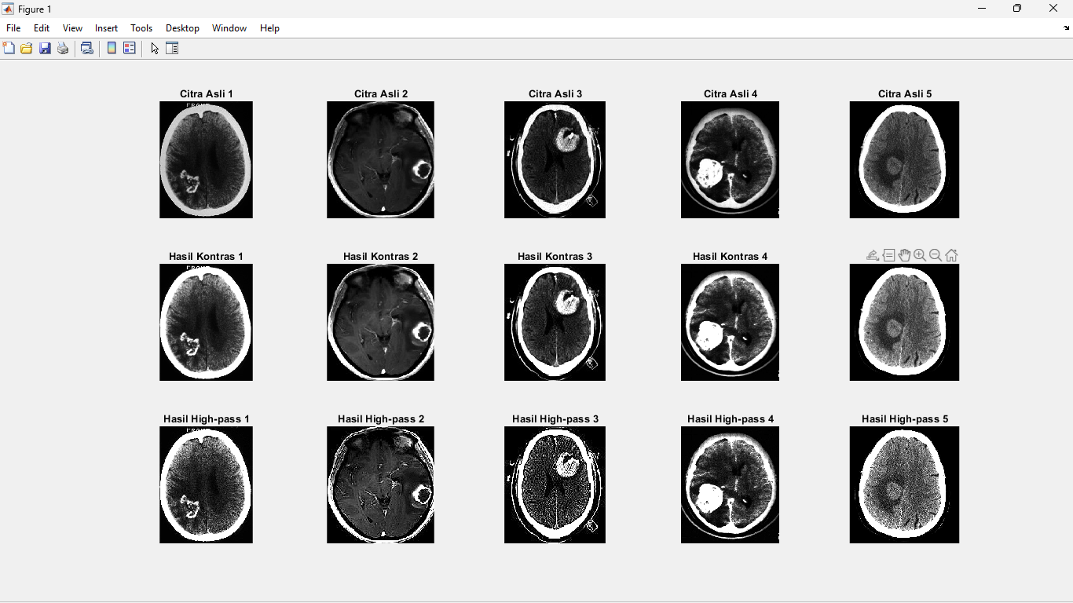**Output :**

**Akurasi, MSE, PNSR** :

1. **Metrik untuk Asli ke Kontras**:

**Objek 1:**

Akurasi: 82.5976

Sensitivitas: 100.0000

Spesifisitas: 82.5929

MSE: 947.3073

PSNR: 18.2975

**Objek 2:**

Akurasi: 96.3458

Sensitivitas: 100.0000

Spesifisitas: 96.3042

MSE: 503.7463

PSNR: 21.1087

**Objek 3:**

Akurasi: 93.1475

Sensitivitas: 100.0000

Spesifisitas: 92.5808

MSE: 442.8517

PSNR: 21.6682

**Objek 4:**

Akurasi: 91.0566

Sensitivitas: 100.0000

Spesifisitas: 90.6626

MSE: 819.6793

PSNR: 18.9944

**Objek 5:**

Akurasi: 97.7334

Sensitivitas: 100.0000

Spesifisitas: 97.4298

MSE: 704.9167

PSNR: 19.6494

1. **Metrik untuk Kontras ke High-pass:**

**Objek 1:**

Akurasi: 99.0625

Sensitivitas: 99.9383

Spesifisitas: 98.8777

MSE: 756.3238

PSNR: 19.3437

**Objek 2:**

Akurasi: 97.8610

Sensitivitas: 99.6162

Spesifisitas: 97.7728

MSE: 2573.7164

PSNR: 14.0252

**Objek 3:**

Akurasi: 96.9604

Sensitivitas: 99.8759

Spesifisitas: 96.4664

MSE: 12281.5839

PSNR: 7.2383

**Objek 4:**

Akurasi: 98.8835

Sensitivitas: 99.2053

Spesifisitas: 98.8348

MSE: 183.5123

PSNR: 25.4942

**Objek 5:**

Akurasi: 99.0996

Sensitivitas: 99.9580

Spesifisitas: 98.9590

MSE: 945.5894

PSNR: 18.3738

1. **Metrik untuk Citra Asli ke High Pass tanpa melalui kontras:**

**Objek 1:**

Akurasi: 98.2921

Sensitivitas: 100.0000

Spesifisitas: 98.2916

MSE: 419.8048

PSNR: 21.8319

**Objek 2**:

Akurasi: 97.2869

Sensitivitas: 96.9767

Spesifisitas: 97.2904

MSE: 1506.1310

PSNR: 16.3522

**Objek 3**:

Akurasi: 94.5983

Sensitivitas: 91.9152

Spesifisitas: 94.8202

MSE: 8161.9715

PSNR: 9.0129

**Objek 4:**

Akurasi: 98.6672

Sensitivitas: 92.9564

Spesifisitas: 98.9188

MSE: 104.3694

PSNR: 27.9451

**Objek 5:**

Akurasi: 98.2737

Sensitivitas: 92.3308

Spesifisitas: 99.0695

MSE: 593.8253

PSNR: 20.3942